

CSA1109-Object Oriented Analysis and Design

CO-3 AT -2

Case Study

Ashmi P S
192571004
4.Smart Renewable Energy Monitoring System
1. Use Case Diagram
Actors
- Consumer
- Maintenance Engineer
- Administrator
- Energy Sensor — external/device actor
- Mobile Application — system interface
Main Use Cases
Consumer
- Monitor Electricity Usage
- View Energy Consumption
- Monitor Battery Status
Maintenance Engineer
- Receive Failure Alerts
- Monitor Equipment Status
- Perform Maintenance
Administrator
- Manage Renewable Resources
- Generate Monthly Energy Report
- Monitor Energy Production
Energy Sensor
- Monitor Solar Power Generation
- Monitor Wind Power Generation
- Monitor Battery Storage
- Monitor Energy Consumption
- Send Energy Data
Important relationships
- Monitor Electricity Usage includes View Energy Consumption
- Monitor Electricity Usage includes Monitor Battery Status
- Equipment Failure includes Send Failure Alert
- Generate Monthly Energy Report includes Collect Energy Data
- Solar Panel and Wind Turbine → Generate Energy
- Energy Sensor → Monitor Energy
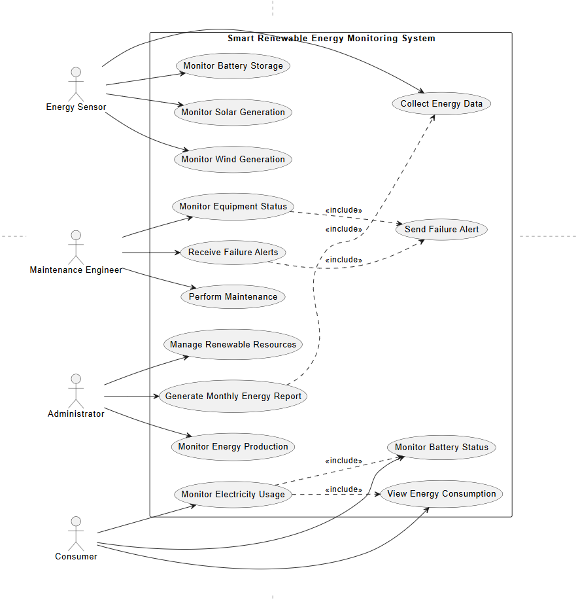
2. Class Diagram
Major Classes
1. Consumer
Attributes
- consumerId
- name
- email
- phone
Methods
- monitorUsage()
- viewConsumption()
- viewBatteryStatus()
2. EnergySensor
Attributes
- sensorId
- sensorType
- location
- status
Methods
- collectData()
- sendData()
3. SolarPanel
Attributes
- panelId
- capacity
- location
- status
Methods
- generatePower()
- getStatus()
4. WindTurbine
Attributes
- turbineId
- capacity
- location
- status
Methods
- generatePower()
- getStatus()
5. BatteryStorage
Attributes
- batteryId
- capacity
- currentLevel
- status
Methods
- storeEnergy()
- releaseEnergy()
- getBatteryLevel()
6. EnergyConsumption
Attributes
- consumptionId
- consumerId
- unitsConsumed
- date
Methods
- calculateConsumption()
- getUsage()
7. MaintenanceEngineer
Attributes
- engineerId
- name
- specialization
- contact
Methods
- monitorEquipment()
- receiveAlert()
- performMaintenance()
8. FailureAlert
Attributes
- alertId
- equipmentId
- alertType
- alertDate
- status
Methods
- generateAlert()
- sendAlert()
9. Administrator
Attributes
- adminId
- name
- email
Methods
- manageResources()
- generateReport()
10. EnergyReport
Attributes
- reportId
- month
- totalProduction
- totalConsumption
- generatedDate
Methods
- generateReport()
- exportReport()

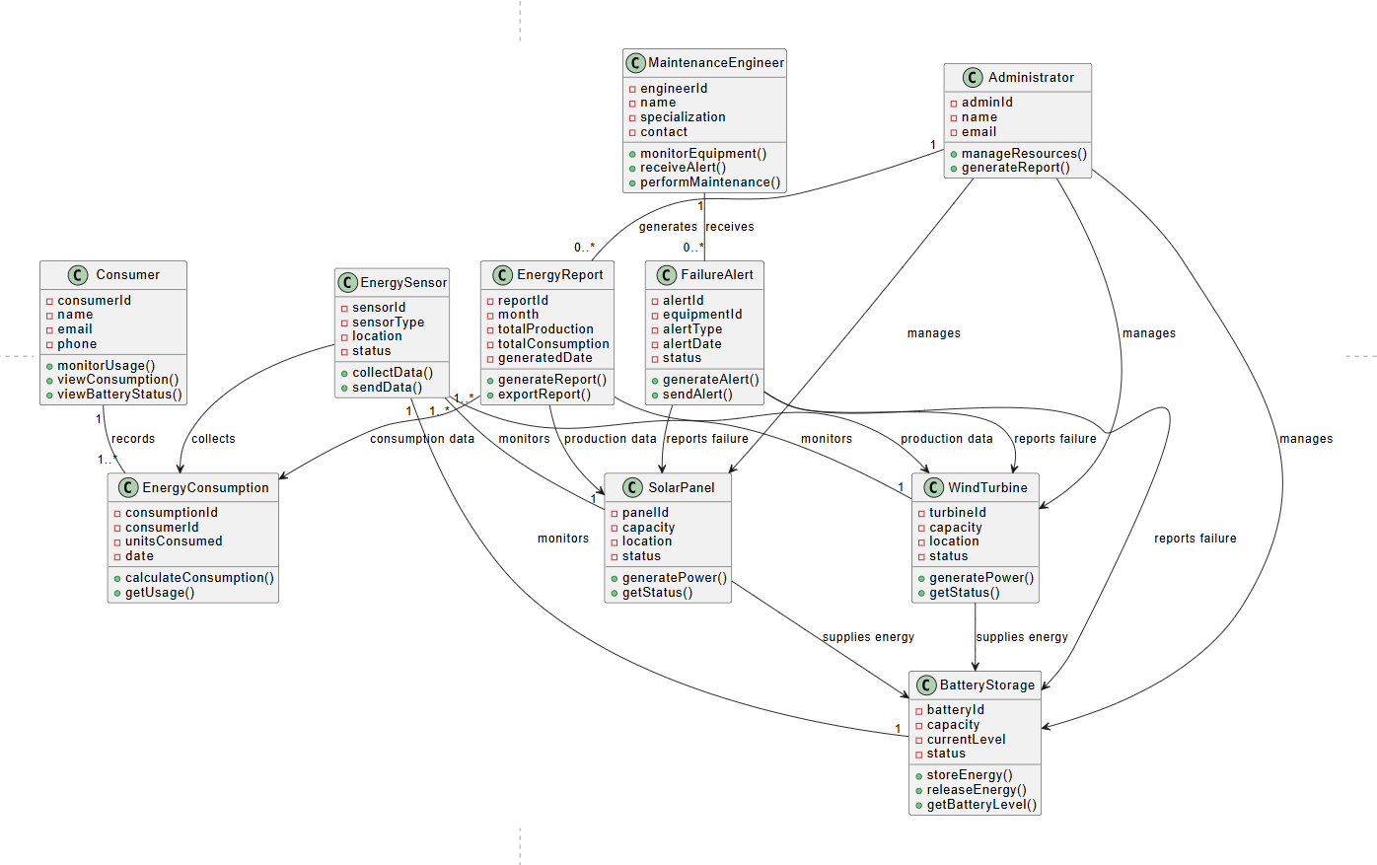
4. UML Relationships to mention in assessment
Relationship | UML | Example
Association | -- | Consumer — EnergyConsumption
Dependency | --> | EnergySensor → EnergyConsumption
Include | <<include>> | Report → Collect Energy Data
Multiplicity | 1..*, 0..* | Engineer → FailureAlert
Generalization | `-- | >`

